

Explanation using structures

−

Definition

−

Contents

File System

What is a Database



directories that are stored in a database table.

The Database File System(DBFS) is placed on top of the files and



manage files stored in the Database.

It is a feature provided to us by Oracle. It basically helps us access and



A Database File System

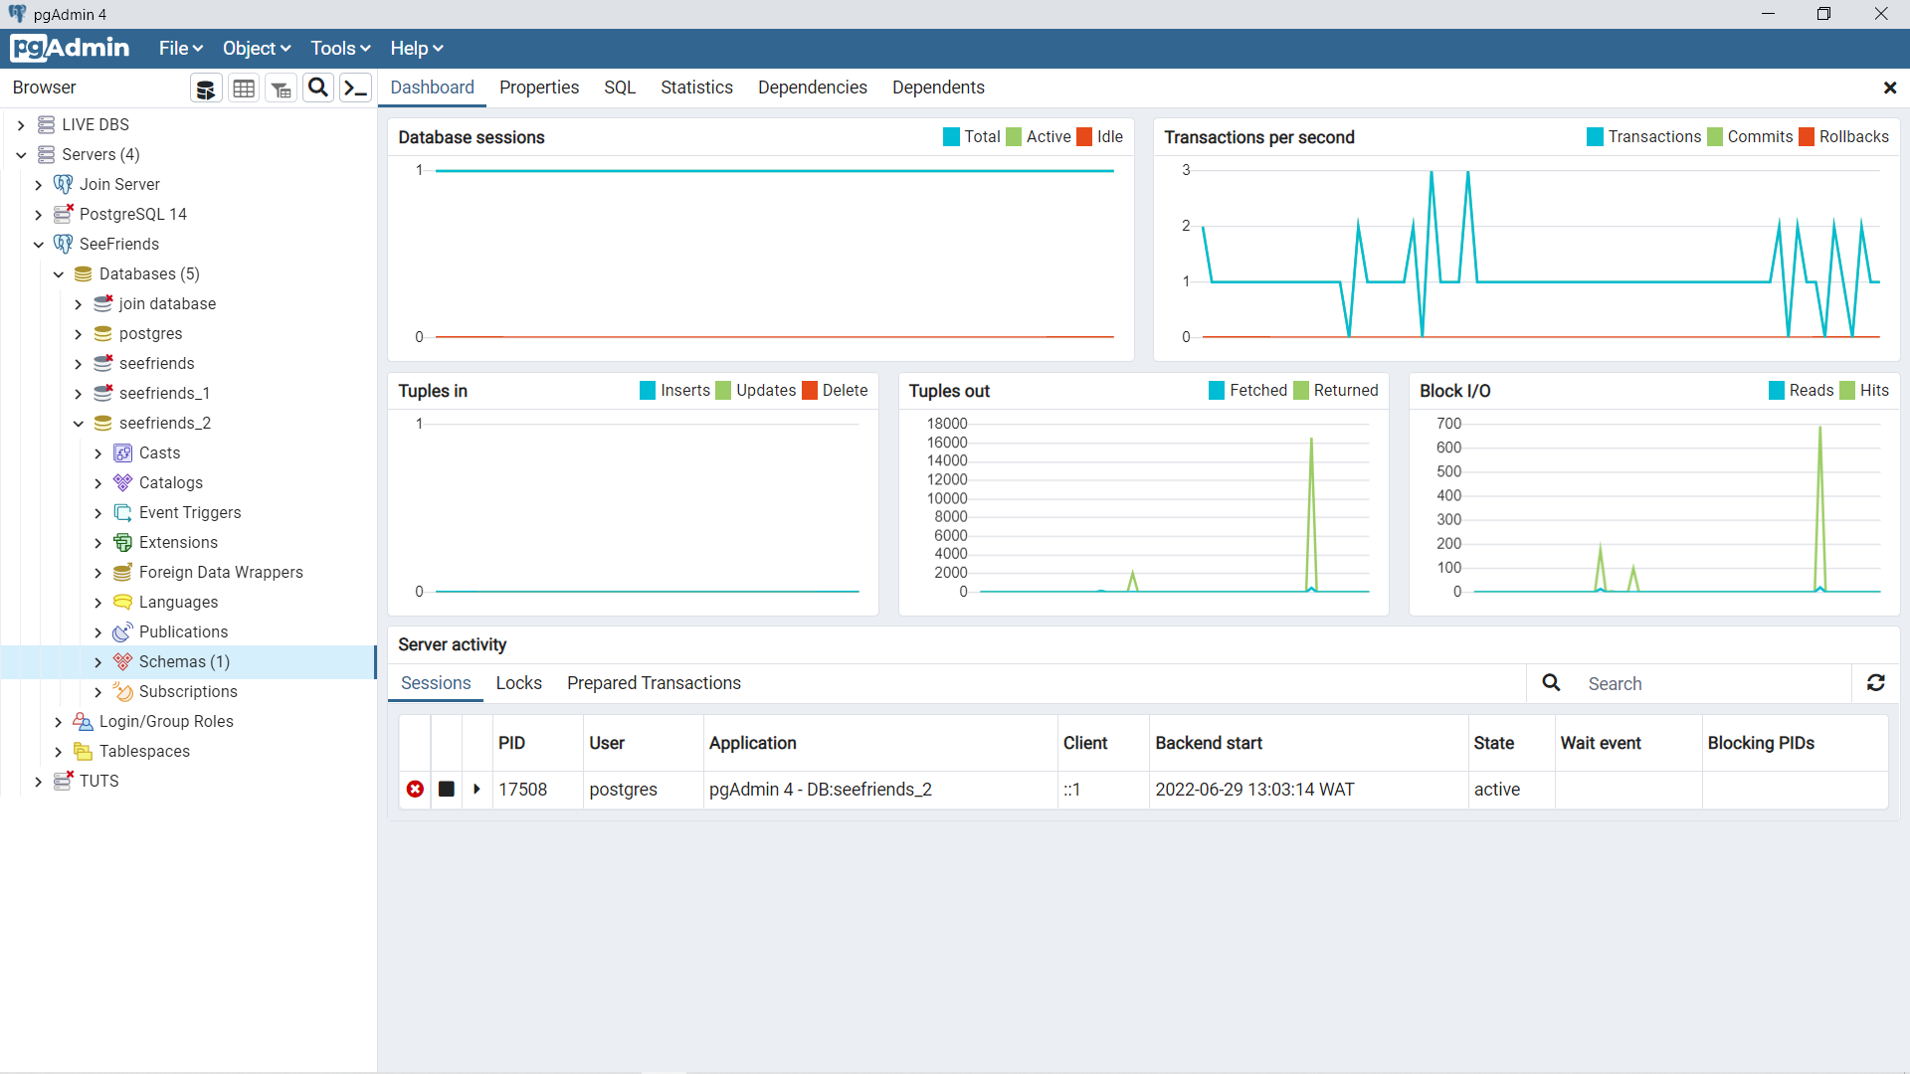

directory that holds all the tables to this database seefriends_2.

Inside our database > schemas: is where we can find our tables



The below diagrams show database structure of an application.



The Structure of A Database

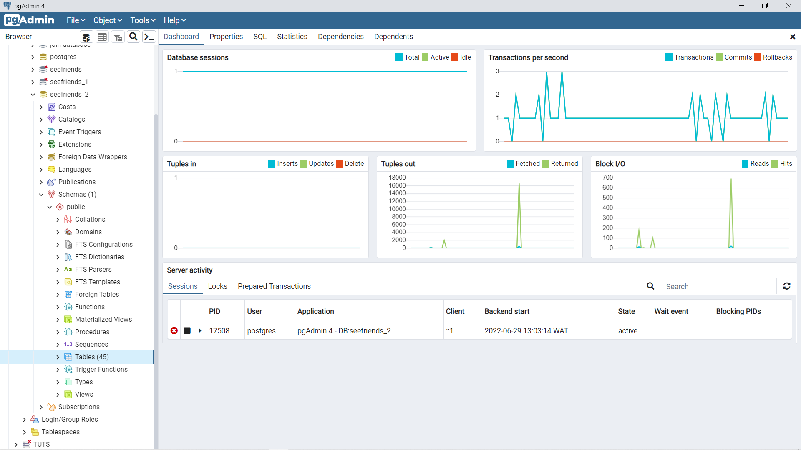

tables

which we have our database tables directory populated with over 40

Inside our Schemas > Public: we see several related objects amongst



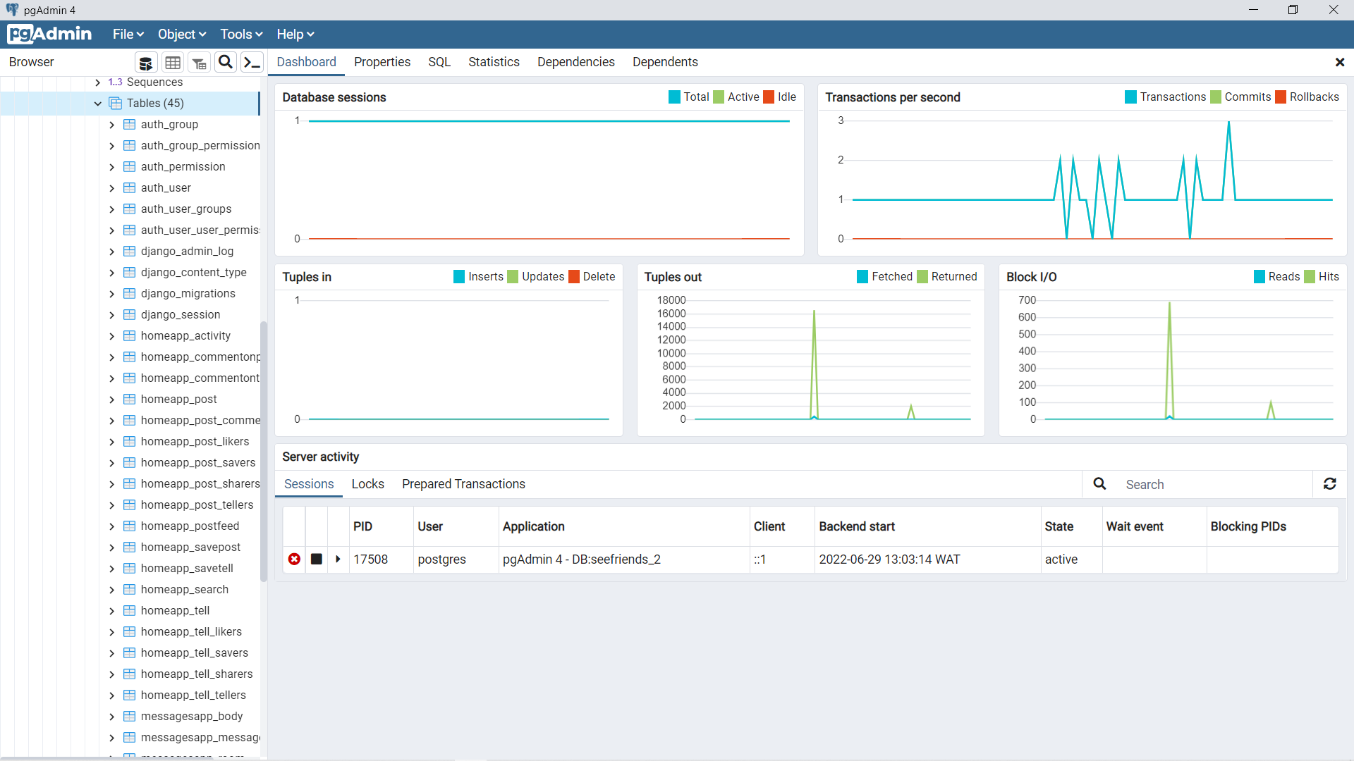

the data to several important parts of our application.

Now inside our database directory, we have several database tables holding



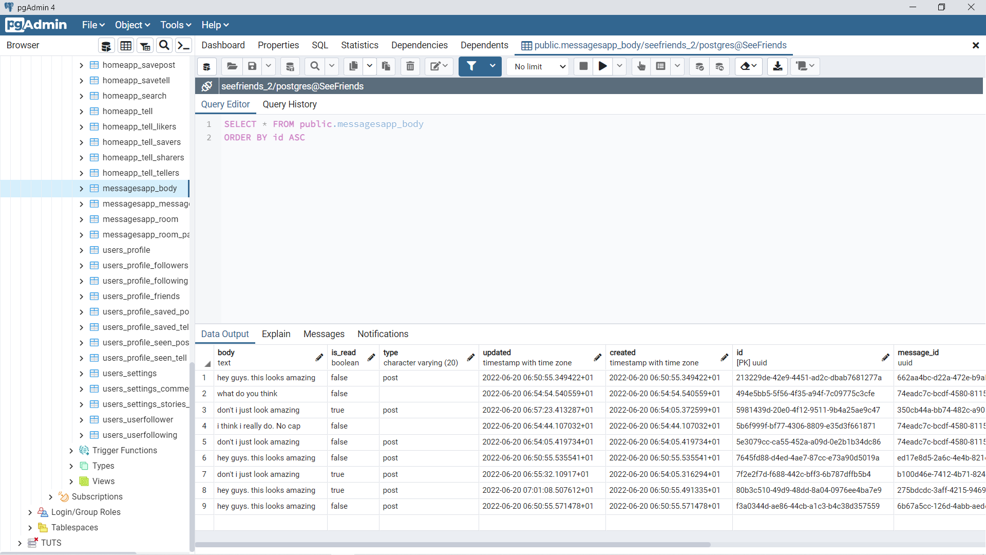

confidential data 😑.

If we open one of the database tables we would get access to some pretty



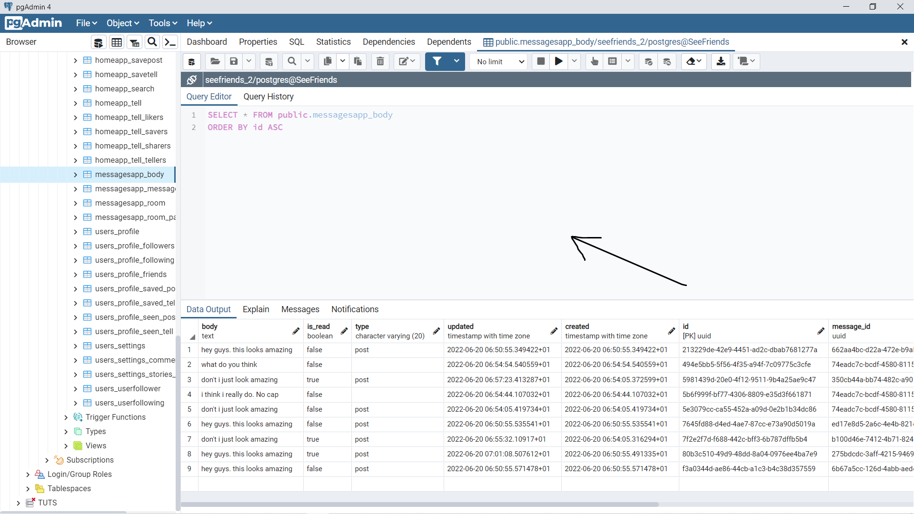

that.

the database table we see. But you would have to know some SQL to do

The field we see below can be used to directly manage the contents of





uses a DBFS we can access our data stored in our database table and

Thank you



COMPUTER SCIENCE



BHU/20/O4/05/0010



Chukwu Daniel Nonso



Made by



also manage those data.

With the above structures shown. Using the pgadmin application that

